IFB130 Database Management

Samuel Groves Crittle: N9978810 Doug Brennan: N7326645

IFB130 Database Management Assignment 2A

2017

**Task 1**

The database for Treasure Hunter is modelled in Figure 1. The diagram is based on the information provided by Aggity Games.

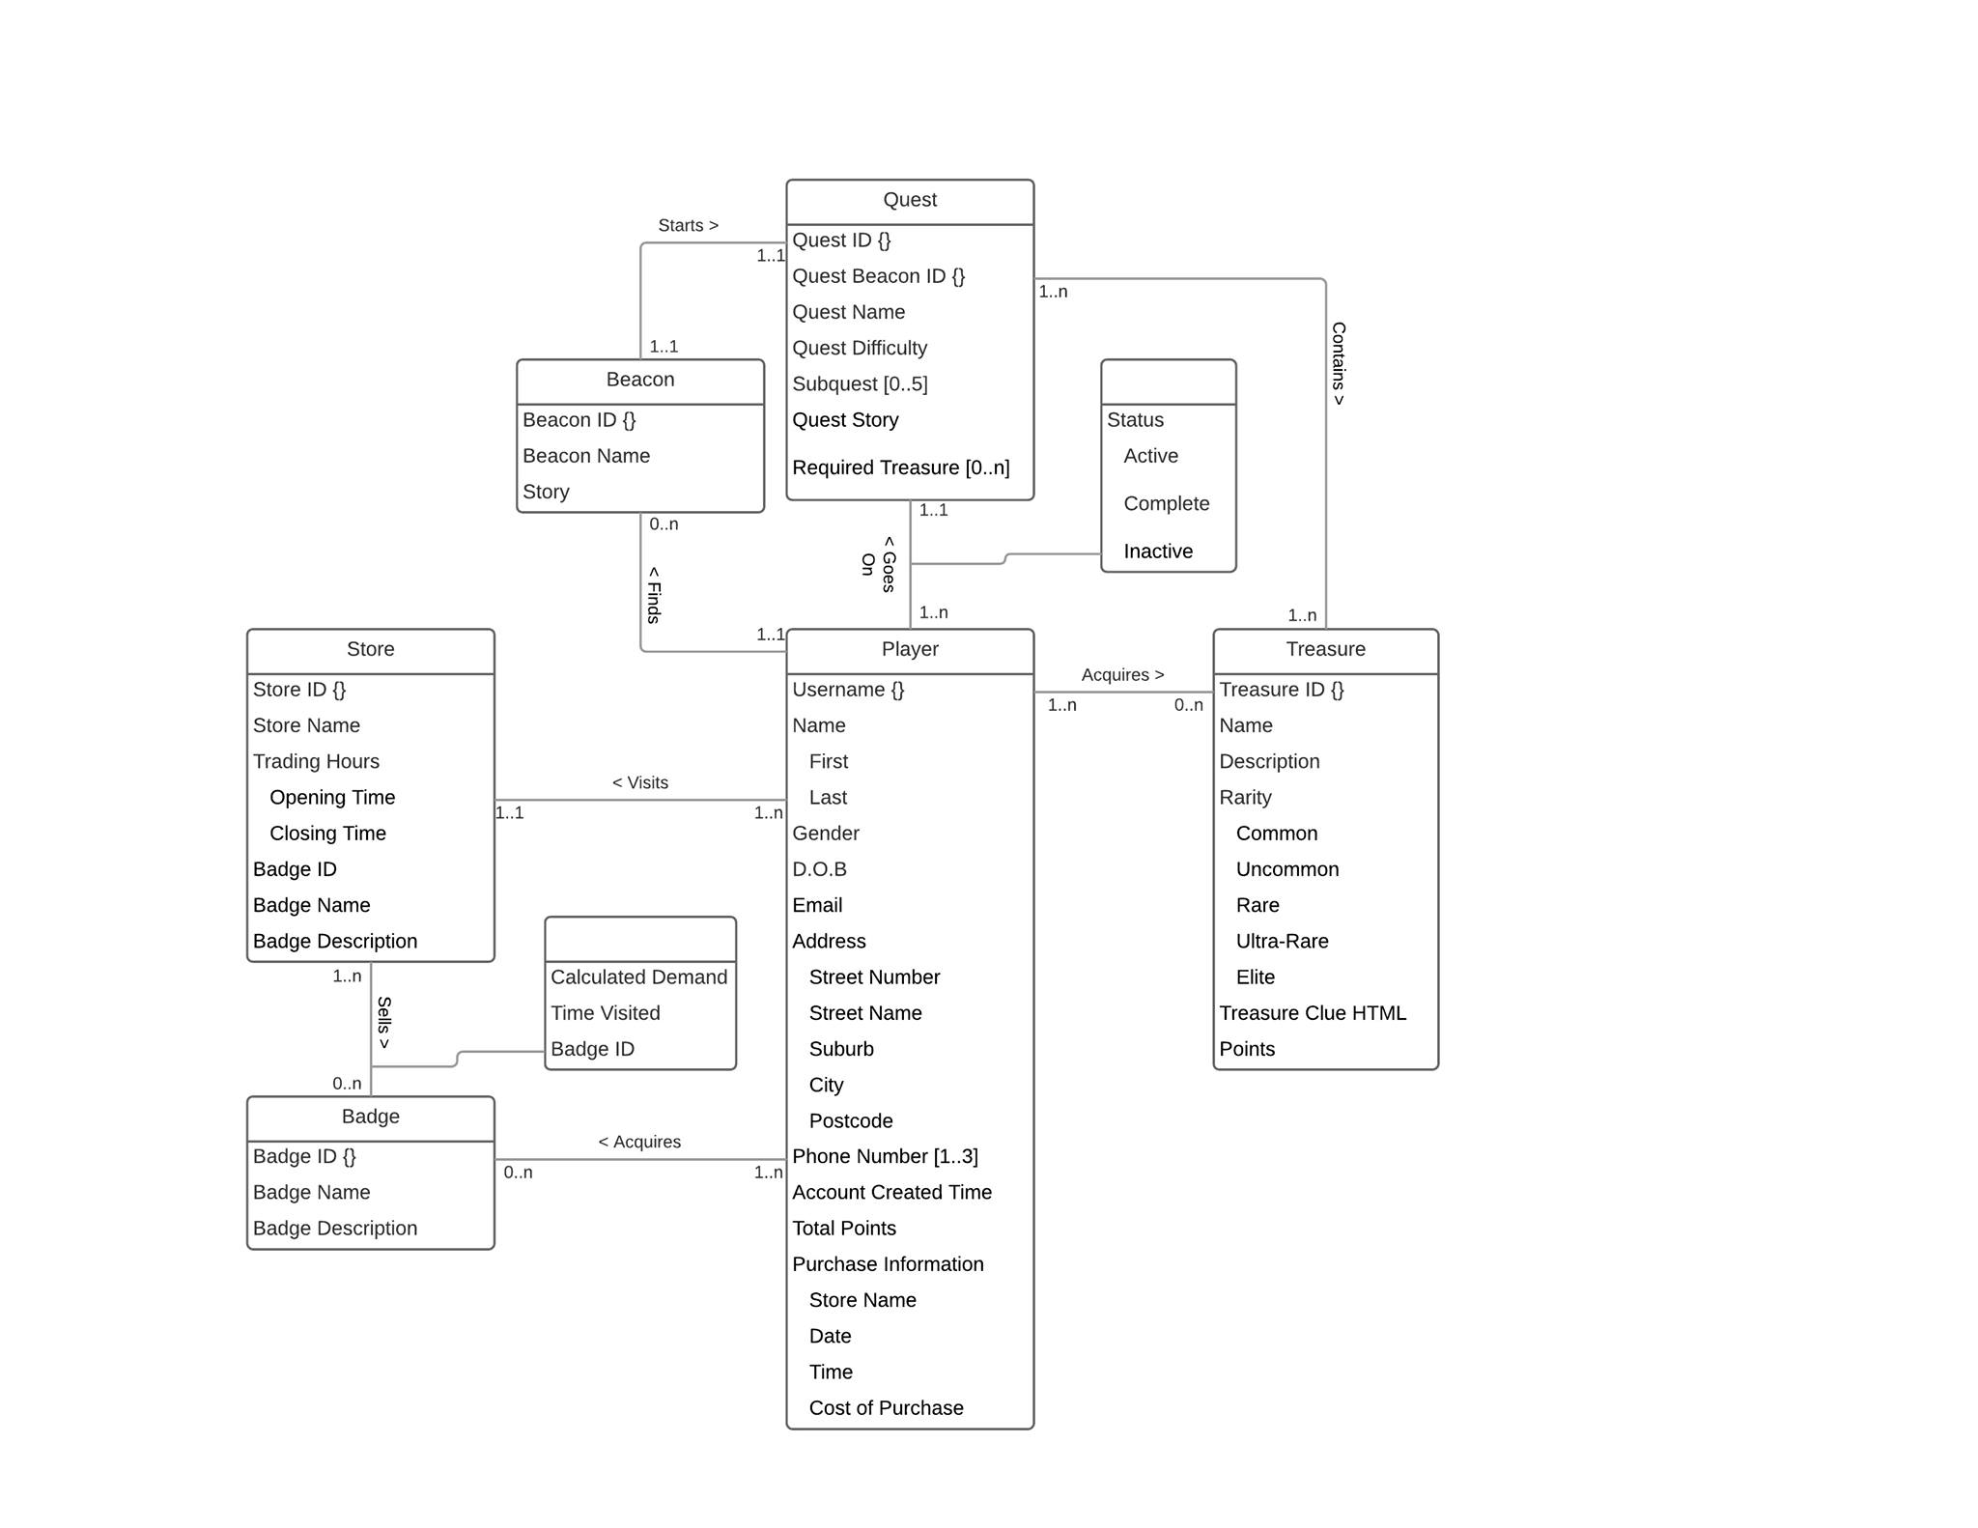

Figure 1: Entity Relationship Diagram of the Treasure Hunter Database

**Task 2**

**Relational model**

**Deriving Entity types**

The entity type Player, becomes the following relation:

Player (Username {}, First name, Last name, Gender, D.O.B, Email, Street number, Street name, Suburb, City, Postcode, Phone Number, Account created time, Total points, Store name, Date, Time, Cost of purchase)

The entity type Quest, becomes the following relation:

Quest (Quest ID {}, Quest Beacon ID {}, Quest Name, Quest Difficulty, Subquest, Quest Story, Required Treasure)

The entity type Beacon, becomes the following relation:

Beacon (Beacon ID {}, Beacon Name, Story)

The entity type Treasure, becomes the following relation:

Treasure (Treasure ID {}, Name, Description, Common, Uncommon, Rare, Ultra-rare, Elite, Treasure Clue HTML, Points)

**Deriving Relationship types**

Goes on was derived by adding Quest with Username {}, Treasure ID {} and Beacon ID {} as foreign keys to link with Player, Beacon and treasure because of the many to many relationship.

Starts was derived by merging Beacon and Quest due to the One to One relationship.

**Relations in the Final Relational Model**

The entity type Player, becomes the following relation:

Player (Username {}, First name, Last name, Gender, D.O.B, Email, Street number, Street name, Suburb, City, Postcode, Account created time, Total points, Store name, Date, Time, Cost of purchase)

The entity type Quest, becomes the following relation:

Quest (Quest ID {}, Quest Beacon ID {}, Quest Name, Quest Difficulty, Subquest, Quest Story, Required Treasure, Username {}, Treasure ID {}, Beacon ID {})

The entity type Beacon, becomes the following relation:

Beacon (Beacon ID {}, Beacon Name, Story, Username {})

The entity type Treasure, becomes the following relation:

Treasure (Treasure ID {}, Name, Description, Common, Uncommon, Rare, Ultra-rare, Elite, Treasure Clue HTML, Points, Username {})

The entity type Phone Number, becomes the following relation:

Phonenumbers (Phonenumber, Username {})

**Foreign keys**

Beacon (Username {}) is dependent on Player (Username {})

Treasure (Username {}) is dependent on Player (Username {})

Quest (Username {}) is dependent on Player (Username {})

Quest (Treasure ID {}) is dependent on Treasures (Treasure ID {})

Quest (Beacon ID {}) is dependent on Beacon (Beacon ID {})

**Constraints**

The first constraint assumes that the Quest is either Active, Complete or Inactive. It cannot be in any other state.

The second constraint is for the Subquest Attribute within the Quest relation, this states that the Subquest can only be between the domain of 0 to 5.

Another constraint is the creation date cannot be in the future, it must be a date that is either current or past.

**Task 3**

The relation used to model the data in this table is for the entity Player.

|  |  |  |  |  |  |  |  |  |  |  |  |  |  |  |  |  |  |  |
| --- | --- | --- | --- | --- | --- | --- | --- | --- | --- | --- | --- | --- | --- | --- | --- | --- | --- | --- |
| Username | First Name | Last Name | Gender | DoB | Email | Street number | Street Name | Suburb | Postcode | City | Phone Number | Creation date | Creation time | Total points | Store  Name | Date | Time | Cost |
| Rooney12 | Wayne | Rollen | Male | 12/09/96 | Roonz@  gmail.com | 12 | Pole | West  end | 4101 | Bris | 0404040 | 19/06/17 | 19:48 | 1200 | Boozer | 9/6/17 | 19:41 | $12 |
| Callum78 | Callum | John | Male | 19/03/99 | Cal78@  msn.com | 15 | Rock | South  Bris | 4101 | Bris | 0404040 | 17/09/16 | 17:32 | 980 | Loco  Lomo | 7/9/16 | 17:31 | $19 |
| Fitzy69 | John | Fitz | Male | 01/07/93 | Fitzy69@  msn.com | 345 | Lamp | Indro | 4532 | Bris | 0404040 | 07/07/15 | 22:45 | 1198 | Crazy  Lemon | 7/7/15 | 22:41 | $24 |
| Nolzey_4 | Steven | Nole | Male | 15/01/46 | Nolzey@  Gmail.com | 389 | Pill | South  bank | 4101 | Bris | 0404040 | 11/09/16 | 16:56 | 205 | Spicy  Donuts | 1/9/16 | 16:51 | $78 |

From this data, a delete operation that would run successfully would be as such:

|  |  |  |  |  |  |  |  |  |  |  |  |  |  |  |  |  |  |  |
| --- | --- | --- | --- | --- | --- | --- | --- | --- | --- | --- | --- | --- | --- | --- | --- | --- | --- | --- |
| Username | First Name | Last Name | Gender | DoB | Email | Street number | Street Name | Suburb | Postcode | City | Phone Number | Creation date | Creation time | Total points | Store  Name | Date | Time | Cost |
| Rooney12 | Wayne | Rollen | Male | 12/09/96 | Roonz@  gmail.com | 12 | Pole | West  end | 4101 | Bris | 0404040 | 19/06/17 | 19:48 | 1200 | Boozer | 9/6/17 | 19:41 | $12 |
| Callum78 | Callum | John | Male | 19/03/99 | Cal78@  msn.com | 15 | Rock | South  Bris | 4101 | Bris | 0404040 | 17/09/16 | 17:32 | 980 | Loco  Lomo | 7/9/16 | 17:31 | $19 |
| Fitzy69 | John | Fitz | Male | 01/07/93 | Fitzy69@  msn.com | 345 | Lamp | Indro | 4532 | Bris | 0404040 | 07/07/15 | 22:45 | 1198 | Crazy  Lemon | 7/7/15 | 22:41 | $24 |
| Nolzey_4 | Steven | Nole | Male | 15/01/46 | Nolzey@  Gmail.com | 389 | Pill | South  bank | 4101 | Bris | 0404040 | 11/09/16 | 16:56 | 205 | Spicy  Donuts | 1/9/16 | 16:51 | $78 |

|  |  |  |  |  |  |  |  |  |  |  |  |  |  |  |  |  |  |  |
| --- | --- | --- | --- | --- | --- | --- | --- | --- | --- | --- | --- | --- | --- | --- | --- | --- | --- | --- |
| Username | First Name | Last Name | Gender | DoB | Email | Street number | Street Name | Suburb | Postcode | City | Phone Number | Creation date | Creation time | Total points | Store  Name | Date | Time | Cost |
| Rooney12 | Wayne | Rollen | Male | 12/09/96 | Roonz@  gmail.com | 12 | Pole | West  end | 4101 | Bris | 0404040 | 19/06/17 | 19:48 | 1200 | Boozer | 9/6/17 | 19:41 | $12 |
| Fitzy69 | John | Fitz | Male | 01/07/93 | Fitzy69@  msn.com | 345 | Lamp | Indro | 4532 | Bris | 0404040 | 07/07/15 | 22:45 | 1198 | Crazy  Lemon | 7/7/15 | 22:41 | $24 |
| Nolzey_4 | Steven | Nole | Male | 15/01/46 | Nolzey@  Gmail.com | 389 | Pill | South  bank | 4101 | Bris | 0404040 | 11/09/16 | 16:56 | 205 | Spicy  Donuts | 1/9/16 | 16:51 | $78 |

From this data, an update operation that would run successfully would be as such:

|  |  |  |  |  |  |  |  |  |  |  |  |  |  |  |  |  |  |  |
| --- | --- | --- | --- | --- | --- | --- | --- | --- | --- | --- | --- | --- | --- | --- | --- | --- | --- | --- |
| Username | First Name | Last Name | Gender | DoB | Email | Street number | Street Name | Suburb | Postcode | City | Phone Number | Creation date | Creation time | Total points | Store  Name | Date | Time | Cost |
| Rooney12 | Wayne | Rollen | Male | 12/09/96 | Roonz@  gmail.com | 12 | Pole | West  end | 4101 | Bris | 0404040 | 19/06/17 | 19:48 | 1200 | Boozer | 9/6/17 | 19:41 | $12 |
| Callum78 | Callum | John | Male | 19/03/99 | Cal78@  msn.com | 15 | Rock | South  Bris | 4101 | Bris | 0404040 | 17/09/16 | 17:32 | 980 | Loco  Lomo | 7/9/16 | 17:31 | $19 |
| Fitzy69 | John | Fitz | Male | 01/07/93 | Fitzy69@  msn.com | 345 | Lamp | Indro | 4532 | Bris | 0404040 | 07/07/15 | 22:45 | 1198 | Crazy  Lemon | 7/7/15 | 22:41 | $24 |
| Nolzey_4 | Steven | Nole | Male | 15/01/46 | Nolzey@  Gmail.com | 389 | Pill | South  bank | 4101 | Bris | 0404040 | 11/09/16 | 16:56 | 205 | Spicy  Donuts | 1/9/16 | 16:51 | $78 |

|  |  |  |  |  |  |  |  |  |  |  |  |  |  |  |  |  |  |  |
| --- | --- | --- | --- | --- | --- | --- | --- | --- | --- | --- | --- | --- | --- | --- | --- | --- | --- | --- |
| Username | First Name | Last Name | Gender | DoB | Email | Street number | Street Name | Suburb | Postcode | City | Phone Number | Creation date | Creation time | Total points | Store  Name | Date | Time | Cost |
| Rooney12 | Wayne | Rollen | Female | 12/09/96 | Roonz@  gmail.com | 12 | Pole | West  end | 4101 | Bris | 0404040 | 19/06/17 | 19:48 | 1200 | Boozer | 9/6/17 | 19:41 | $12 |
| Callum78 | Callum | John | Male | 19/03/99 | Cal78@  msn.com | 15 | Rock | South  Bris | 4101 | Bris | 0404040 | 17/09/16 | 17:32 | 980 | Loco  Lomo | 7/9/16 | 17:31 | $19 |
| Fitzy69 | John | Fitz | Male | 01/07/93 | Fitzy69@  msn.com | 345 | Lamp | Indro | 4532 | Bris | 0404040 | 07/07/15 | 22:45 | 1198 | Crazy  Lemon | 7/7/15 | 22:41 | $24 |
| Nolzey_4 | Steven | Nole | Male | 15/01/46 | Nolzey@  Gmail.com | 389 | Pill | South  bank | 4101 | Bris | 0404040 | 11/09/16 | 16:56 | 205 | Spicy  Donuts | 1/9/16 | 16:51 | $78 |

From this data, an update operation that would NOT run successfully would be as such:

|  |  |  |  |  |  |  |  |  |  |  |  |  |  |  |  |  |  |  |
| --- | --- | --- | --- | --- | --- | --- | --- | --- | --- | --- | --- | --- | --- | --- | --- | --- | --- | --- |
| Username | First Name | Last Name | Gender | DoB | Email | Street number | Street Name | Suburb | Postcode | City | Phone Number | Creation date | Creation time | Total points | Store  Name | Date | Time | Cost |
| Rooney12 | Wayne | Rollen | Male | 12/09/96 | Roonz@  gmail.com | 12 | Pole | West  end | 4101 | Bris | 0404040 | 19/06/17 | 19:48 | 1200 | Boozer | 9/6/17 | 19:41 | $12 |
| Callum78 | Callum | John | Male | 19/03/99 | Cal78@  msn.com | 15 | Rock | South  Bris | 4101 | Bris | 0404040 | 17/09/16 | 17:32 | 980 | Loco  Lomo | 7/9/16 | 17:31 | $19 |
| Fitzy69 | John | Fitz | Male | 01/07/93 | Fitzy69@  msn.com | 345 | Lamp | Indro | 4532 | Bris | 0404040 | 07/07/15 | 22:45 | 1198 | Crazy  Lemon | 7/7/15 | 22:41 | $24 |
| Nolzey_4 | Steven | Nole | Male | 15/01/46 | Nolzey@  Gmail.com | 389 | Pill | South  bank | 4101 | Bris | 0404040 | 11/09/16 | 16:56 | 205 | Spicy  Donuts | 1/9/16 | 16:51 | $78 |

|  |  |  |  |  |  |  |  |  |  |  |  |  |  |  |  |  |  |  |
| --- | --- | --- | --- | --- | --- | --- | --- | --- | --- | --- | --- | --- | --- | --- | --- | --- | --- | --- |
| Username | First Name | Last Name | Gender | DoB | Email | Street number | Street Name | Suburb | Postcode | City | Phone Number | Creation date | Creation time | Total points | Store  Name | Date | Time | Cost |
| NULL | Wayne | Rollen | Male | 12/09/96 | Roonz@  gmail.com | 12 | Pole | West  end | 4101 | Bris | 0404040 | 19/06/17 | 19:48 | 1200 | Boozer | 9/6/17 | 19:41 | $12 |
| Callum78 | Callum | John | Male | 19/03/99 | Cal78@  msn.com | 15 | Rock | South  Bris | 4101 | Bris | 0404040 | 17/09/16 | 17:32 | 980 | Loco  Lomo | 7/9/16 | 17:31 | $19 |
| Fitzy69 | John | Fitz | Male | 01/07/93 | Fitzy69@  msn.com | 345 | Lamp | Indro | 4532 | Bris | 0404040 | 07/07/15 | 22:45 | 1198 | Crazy  Lemon | 7/7/15 | 22:41 | $24 |
| Nolzey_4 | Steven | Nole | Male | 15/01/46 | Nolzey@  Gmail.com | 389 | Pill | South  bank | 4101 | Bris | 0404040 | 11/09/16 | 16:56 | 205 | Spicy  Donuts | 1/9/16 | 16:51 | $78 |

From this data, an insert operation that would not run successfully would be as such:

|  |  |  |  |  |  |  |  |  |  |  |  |  |  |  |  |  |  |  |
| --- | --- | --- | --- | --- | --- | --- | --- | --- | --- | --- | --- | --- | --- | --- | --- | --- | --- | --- |
| Username | First Name | Last Name | Gender | DoB | Email | Street number | Street Name | Suburb | Postcode | City | Phone Number | Creation date | Creation time | Total points | Store  Name | Date | Time | Cost |
| Rooney12 | Wayne | Rollen | Male | 12/09/96 | Roonz@  gmail.com | 12 | Pole | West  end | 4101 | Bris | 0404040 | 19/06/17 | 19:48 | 1200 | Boozer | 9/6/17 | 19:41 | $12 |
| Callum78 | Callum | John | Male | 19/03/99 | Cal78@  msn.com | 15 | Rock | South  Bris | 4101 | Bris | 0404040 | 17/09/16 | 17:32 | 980 | Loco  Lomo | 7/9/16 | 17:31 | $19 |
| Fitzy69 | John | Fitz | Male | 01/07/93 | Fitzy69@  msn.com | 345 | Lamp | Indro | 4532 | Bris | 0404040 | 07/07/15 | 22:45 | 1198 | Crazy  Lemon | 7/7/15 | 22:41 | $24 |
| Nolzey_4 | Steven | Nole | Male | 15/01/46 | Nolzey@  Gmail.com | 389 | Pill | South  bank | 4101 | Bris | 0404040 | 11/09/16 | 16:56 | 205 | Spicy  Donuts | 1/9/16 | 16:51 | $78 |

|  |  |  |  |  |  |  |  |  |  |  |  |  |  |  |  |  |  |  |
| --- | --- | --- | --- | --- | --- | --- | --- | --- | --- | --- | --- | --- | --- | --- | --- | --- | --- | --- |
| Username | First Name | Last Name | Gender | DoB | Email | Street number | Street Name | Suburb | Postcode | City | Phone Number | Creation date | Creation time | Total points | Store  Name | Date | Time | Cost |
| Rooney12 | Wayne | Rollen | Female | 12/09/96 | Roonz@  gmail.com | 12 | Pole | West  end | 4101 | Bris | 0404040 | 19/06/17 | 19:48 | 1200 | Boozer | 9/6/17 | 19:41 | $12 |
| Callum78 | Callum | John | Male | 19/03/99 | Cal78@  msn.com | 15 | Rock | South  Bris | 4101 | Bris | 0404040 | 17/09/16 | 17:32 | 980 | Loco  Lomo | 7/9/16 | 17:31 | $19 |
| Fitzy69 | John | Fitz | Male | 01/07/93 | Fitzy69@  msn.com | 345 | Lamp | Indro | 4532 | Bris | 0404040 | 07/07/15 | 22:45 | 1198 | Crazy  Lemon | 7/7/15 | 22:41 | $24 |
| Nolzey_4 | Steven | Nole | Male | 15/01/46 | Nolzey@  Gmail.com | 389 | Pill | South  bank | 4101 | Bris | 0404040 | 11/09/16 | 16:56 | 205 | Spicy  Donuts | 1/9/16 | 16:51 | $78 |
| Nolzey_4 | Joe | Blow | Other | 17/01/96 | Joey@  Gmail.com | 87 | Lank | South  Bris | 4101 | Bris | 0404040 | 28/11/17 | 16:56 | 205 | Spicy  Donuts | 1/9/16 | 16:51 | $78 |

This would be an unsuccessful insertion due to the username being the same as a previous member and also the creation date is in the future which is not possible due to the constraints listed in task 2.

**Task 4**

**A:**

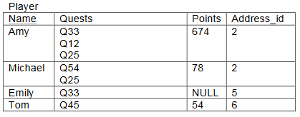

**Form**: 0NF

**Reason**: The relation contains a repeating group (Quests) which limits the form reaching 1NF.

**B:**

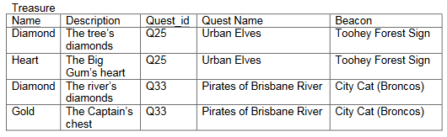

**Form**: 1NF

**Reason**: The intersection of each row and each column contains one and only one value, the lack of a primary key prevents the form reaching 2NF.

**C:**

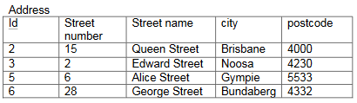

**Form**: 3NF

**Reason**: The Address relation is 1NF and 2NF resulting in 3NF. 1NF is satisfied for the intersection of each row and column contains only one value. 2NF is satisfied for every non-primary key attribute is fully functional dependant on the primary key. The outcome of these two satisfactions results in the relation reaching 3NF.